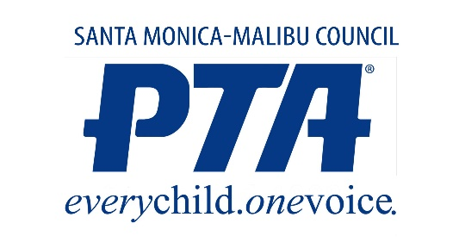
Warrant / Check Request
Check No: ______________
Date: ______________

The Treasurer of Santa Monica-Malibu PTA Council
Will Please Pay
AMOUNT |  | $
For
Please mail check to
Enter accounts/
categories and
amounts for each
receipt
 | TOTAL

President: __________________________________ Date: __________________________________
Gabrielle Cohen, SMMPTA President 2021-22
Secretary: __________________________________ Date: __________________________________
Jennifer Brockett, SMMPTA Secretary 2021-22
Please scan copies of receipts/invoices and email to:

Diana Oliver - SMMPTA Council Treasurer @
smmptatreasurer@gmail.com

Alternately, you can attach original receipts/invoices and email to:
SMMPTA Council
ATTN: Diana Oliver, Treasurer
307 Montana Ave., Apt. 302
Santa Monica, CA 90403

